Iterator pattern

Iterator pattern is very commonly used design pattern in Java and .Net programming environment. This pattern is used to get a way to access the elements of a collection object in sequential manner without any need to know its underlying representation.
Iterator pattern falls under behavioral pattern category.

Implementation
We're going to create a Iterator interface which narrates navigation method and a Container interface which retruns the iterator . Concrete classes implementing the Container interface will be responsible to implement Iterator interface and use it
IteratorPatternDemo, our demo class will use NamesRepository, a concrete class implementation to print a Names stored as a collection in NamesRepository.
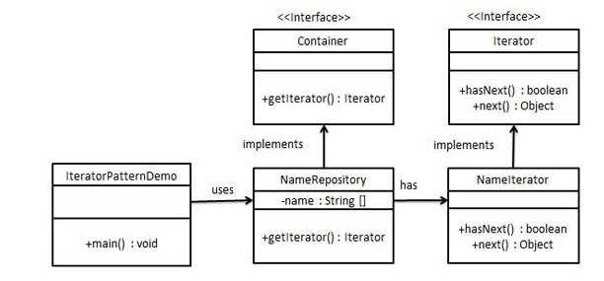
package com.desing.pattern.iterator;

public interface Container {
Iterator getIterator();
}

package com.desing.pattern.iterator;

public interface Iterator {

boolean hasNext();
Object next();

}
package com.desing.pattern.iterator;

public class NamedRepository implements Container {

String[] names = { "Sanjeev", "Abhi", "Suresh" };

@Override
public Iterator getIterator() {
return new NamedIterator();
}

private class NamedIterator implements Iterator {
int index;

@Override
public boolean hasNext() {

if (index < names.length)
return true;
return false;
}

@Override
public Object next() {
if (this.hasNext())
return names[index++];
return null;
}

}

}
}
package com.desing.pattern.iterator;

public class TestIterator {

public static void main(String args[]) {
NamedRepository namedRepository = new NamedRepository();

Iterator iterator = namedRepository.getIterator();
while (iterator.hasNext()) {
System.out.println(iterator.next());
}
}

}

